Company 4 Business Plan

QLeapTM

***Take a Quantum Leap Forward***

[QLeap™ Website](https://maleksfaxi.github.io/Qleap/)

Name 1

Mission 1

Objective 2

Strategy 2

Products 2

Customers 2

Shareholders 2

Organization 3

Action plan 3

Production 3

Marketing 3

Finance 4

Forecasting 4

Financial strategy 4

# Name

Our company name, QLeap™, embodies the concept of a Quantum Leap, reflecting our dedication to pushing boundaries, fostering innovation, and propelling technological advancements. This commitment drives us as we aim for a more sustainable future in the technology industry.

# Mission

At QLeap™, we're dedicated to revolutionizing computer chip production through innovation and sustainability. By developing cutting-edge technologies, we enhance performance while minimizing environmental impact. Our mission is to lead the industry towards a more sustainable future by delivering innovative, high-performance solutions.

***“With QLeap, Take a Quantum Leap Forward”***

# Objective

Our company aims to become a leading semiconductor manufacturer within the Startup Sim universe, focusing on delivering high-performance chips to PC makers and the growing consumer market. We will leverage cutting-edge technology to meet the demands of both sectors, prioritizing innovation, quality, and efficiency to secure a competitive edge.

# Strategy

We plan to specialize in semiconductor production, targeting both B2B markets to maximize reach and profitability. Our strategy includes establishing strong partnerships with PC manufacturers and developing direct sales channels for tech-savvy consumers. We will invest in R&D to stay ahead of technological advancements and optimize our operations for cost-effectiveness, aiming for sustainable growth and shareholder value enhancement.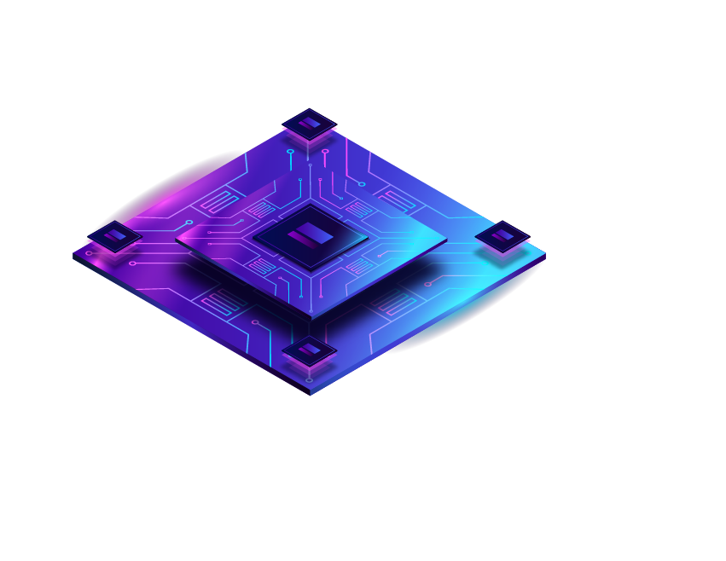

# Products

QLeap™ computer chips are positioned as high-performance, energy-efficient solutions for various computing needs. Our chips encompass :

* **Superior Performance:** QLeap™ chips deliver fast and reliable processing power, enhancing the overall performance of electronic devices.
* **Energy Efficiency:** Designed with advanced technology, QLeap™ chips optimize power consumption, prolonging battery life and reducing environmental impact.
* **Versatility:** QLeap™ chips are versatile, suitable for a wide range of applications including gaming, multimedia editing, data processing, and more.
* **Reliability:** Rigorously tested and manufactured to the highest standards, QLeap™ chips ensure durability and long-term reliability.
* **Compatibility:** QLeap™ chips are compatible with leading hardware and software platforms, providing seamless integration and flexibility for users.

# Customers

Our target customers range from **high-end** businesses and professional users to **individual consumers** seeking advanced semiconductor solutions. We prioritize serving high-end businesses, professional users, and individual consumers, particularly PC manufacturers, enterprises, and end-users with demanding computing needs. We focus on **both B2B and B2C transactions**, collaborating closely with industry partners to integrate our semiconductor solutions into their products, ensuring seamless compatibility and optimal performance for end-users.

# Shareholders

To our shareholders, we ensure our commitment to focus on maximizing shareholder respect through key developments and money-wise measures. Our approach favors both competitive yield payouts and improved share valuations, reflecting our commitment to the growth and soundness of your investment. We are committed to simplifying, managing efficiently and taking advantage of opportunities to improve productivity.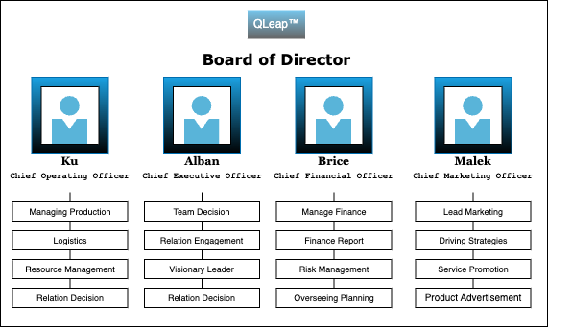

# Organization

# Action plan

### Production

1. **Optimal Grade Production:** We ensure that each plant focuses on producing either the standard or deluxe model for maximum efficiency, especially when owning multiple plants of the same type in an area.
2. **Capacity Utilization:** We strive to operate each plant at an optimal capacity level, falling within the 65% to 85% range, to maximize production without compromising efficiency.
3. **Strategic Plant Construction and Disposal:** We strategically decide when to build new plants and expand to new areas, considering market demand and potential cost reductions through improvements. Additionally, evaluate opportunities to dispose of old plants to Nippon at a reasonable discount.
4. **Chip Production:** We maintain a balanced inventory of chips to facilitate the market, by ensuring that chips are available in the required area and follow a timeline that aligns with the manufacturing process.
5. **R&D Envisioning:** We strategically allocate R&D budgets, to enhance the probability of obtaining higher grades for both chips and PCs, aiming for differentiation and market competitiveness between intra-company.

### Marketing

1. We **keep track** of the **revenue versus price point curve** in order to accurately estimate our ***advertisement expenditure***. ([QLeap™ Website](https://maleksfaxi.github.io/Qleap/))
2. We analyze the Gazette news related to our industry, competitors, and market trends in order to anticipate our market expansion .
3. We also **monitor the effectiveness of advertising campaigns** and adjust strategies as needed.
4. In the future, we also aim to increase our advertising funds to 10% to increase the demand and analyze the return on investment (ROI) of increased advertising expenditure.

### Finance

1. **Financial Strategy:** Developing and overseeing the company's financial strategy, aligning it with long-term business goals.
2. **Risk Management:** Identifying, analyzing, and mitigating financial risks, including those related to currency exchange, interest rates, and international operations.
3. **Financial Reporting:** Ensuring accurate and timely financial reporting in compliance with international accounting standards and regulations.
4. **Capital Structure Management:** Optimizing the mix of debt and equity financing to support international expansion and operations.
5. **Investment Decisions**: Overseeing capital investments, mergers, acquisitions, and divestitures to drive growth and expand the company's global footprint.
6. **Cash Flow Management**: Managing the company's cash flow to ensure operational liquidity and financial health across different markets.
7. **Tax Planning**: Developing strategies to minimize tax liabilities while complying with tax laws in all jurisdictions the company operates.
8. **Stakeholder Communication**: Communicating financial performance and strategy to stakeholders, including investors, board members, and regulatory bodies.

# Forecasting

Simple forecasting over a sample period shows that a more expansive financial strategy MUST be envisaged:

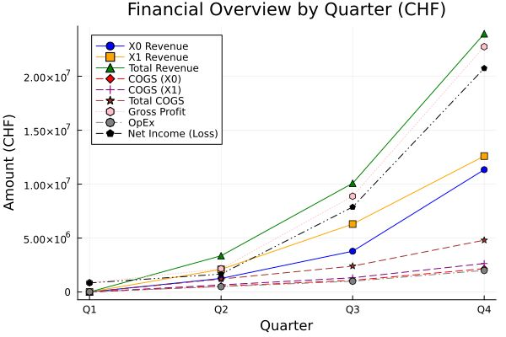

| **Quarters** | **Q1** | **Q2** | **Q3** | **Q4** |
| --- | --- | --- | --- | --- |
| **X0 Revenue** | - | 1,260,000.00 | 3,780,000.00 | 11,340,000.00 |
| **X1 Revenue** | - | 2,100,000.00 | 6,300,000.00 | 12,600,000.00 |
| **Total Revenue** | - | 3,360,000.00 | 10,080,000.00 | 23,940,000.00 |
| **COGS (X0)** | - | 540,800.00 | 1,081,600.00 | 2,163,200.00 |
| **COGS (X1)** | - | 660,000.00 | 1,320,000.00 | 2,640,000.00 |
| **Total COGS** | - | 1,200,800.00 | 1,200,800.00 | 1,200,800.00 |
| **Gross Profit** | 860,000.00 | 2,159,200.00 | 8,879,200.00 | 22,739,200.00 |
| **OpEx** | 20,000.00 | 500,000.00 | 1,000,000.00 | 2,000,000.00 |
| **Net Income (Loss)** | 840,000.00 | 1,659,200.00 | 7,879,200.00 | 20,739,200.00 |

# Financial strategy

A few of the discussed strategies that would need to be tackled for the next exercise:

* **Capital and Expansion Strategy:**

- Allocate funds for building additional factories to boost chip production capacity.

- Secure financing through a mix of equity and debt, targeting strategic investors and low-interest loans, potentially leveraging government incentives for technology manufacturing in the EU.

- Plan for environmentally sustainable manufacturing processes to adhere to EU regulations and qualify for green financing options.

* **EU Market Entry and Growth Strategy:**

- Invest in market research to tailor chip offerings (X0 and X1) to EU standards and customer preferences.

- Set aside a budget for compliance, legal advisories, and establishing a local presence to navigate the regulatory landscape.

- Strategize on marketing and sales to build brand recognition and customer trust in the new market.

* **Diversification and Revenue Strategy:**

- Develop and patent PC assembly technologies, designating resources for R&D and legal protection of intellectual property.

- Establish a licensing revenue model for patented technologies, opening a new stream of income apart from direct chip sales.

* **Financial Management Strategy:**

- Implement a disciplined budgeting process to track and manage operational expenses in line with strategic growth plans.

- Develop a currency risk management plan to mitigate fluctuations between USD and CHF.

- Regularly review and adjust strategic plans based on actual performance and market feedback.

* **Wholesaling Expansion Strategy:**

- Broaden Inventory to add related tech products to complement chip offerings.

- Leverage Logistics to use existing logistics expertise for efficient distribution.

- Strengthen B2B Sales to target manufacturers and retailers with a wholesale catalog.

- Offer Value-Added Services to differentiate with customization and support.

- Adapt Through Analysis to continuously adjust to market demands.

- Establish E-commerce to facilitate ordering and customer service online.

- Utilize Brand Trust to capitalize on the established reputation for quality.